Lab Practical #10:
Study of IP Addressing and sub-netting.
Practical Assignment #10:
- Find default subnet masks, network bits, host bits, hosts per subnet, no of subnets, subnet number, 1st valid IP address, last valid IP address, and broadcast address.
  - 8.1.4.5/16
  - 130.4.102.1/24

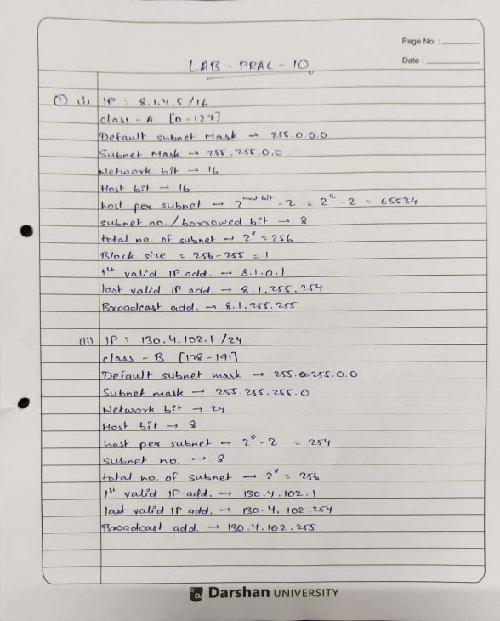

  - 130.4.102.1/22
  - 199.1.1.100/27
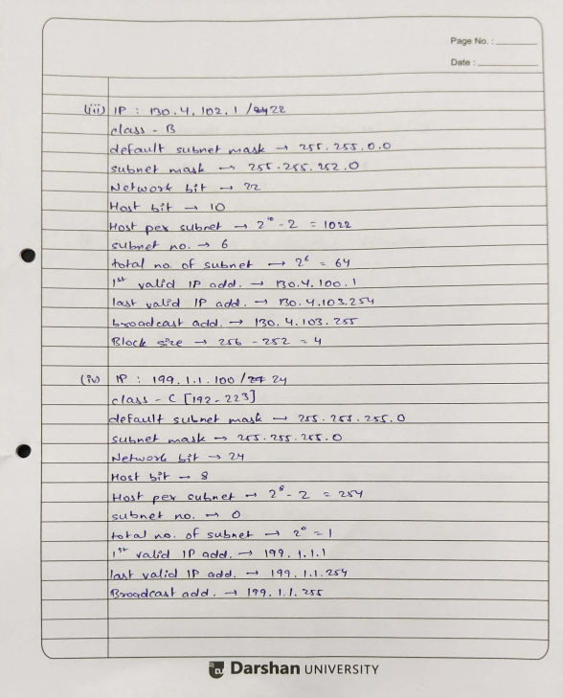

- A host in a class C network has been assigned an IP address 192.168.17.9. Find the number of addresses in the block, the first address, and the last address.

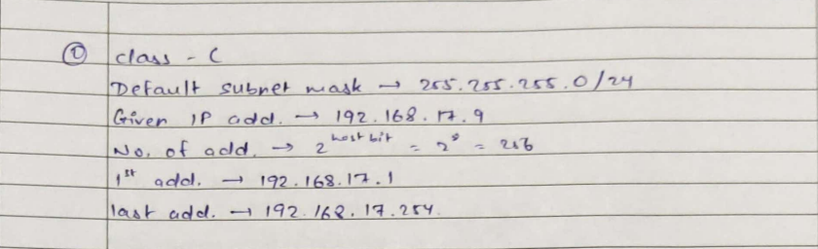

- An address in a block is given as 185.28.17.9. Find the number of addresses in the block, the first address, and the last address.
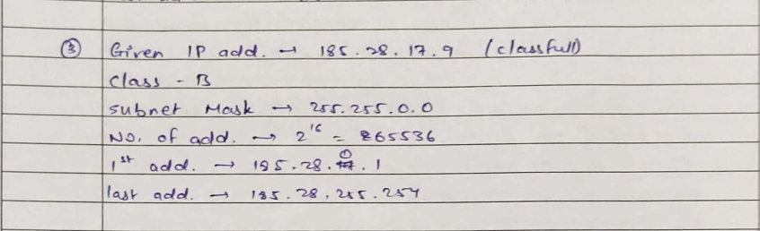

- A block of addresses is granted to a small organization. We know that one of the addresses is 205.16.37.39/28. What is the first address, last address, number of addresses in a block?
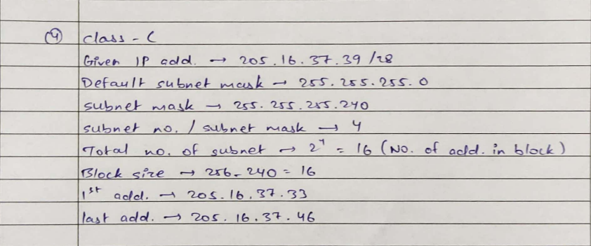

- Subnet the IP address 216.21.5.0 into 30 hosts in each subnet. Find Class, Default Mask, subnet mask, Bit Borrowed, New subnet mask, No. of Hosts & Subnet, Network Ranges (Subnets).
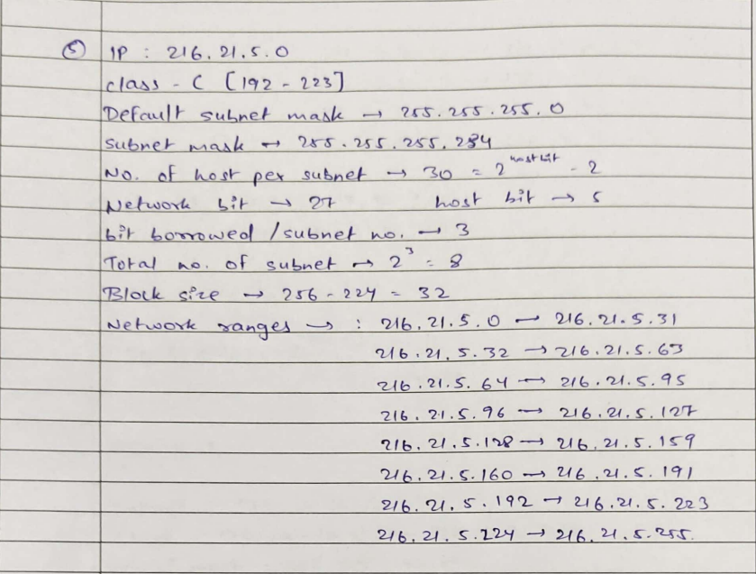

- Subnet the IP address 192.10.20.0 into 52 hosts in each subnet. Find Class, Default Mask, Bit Borrowed, New subnet mask, No. of Hosts & Subnet, Network Ranges (Subnets).
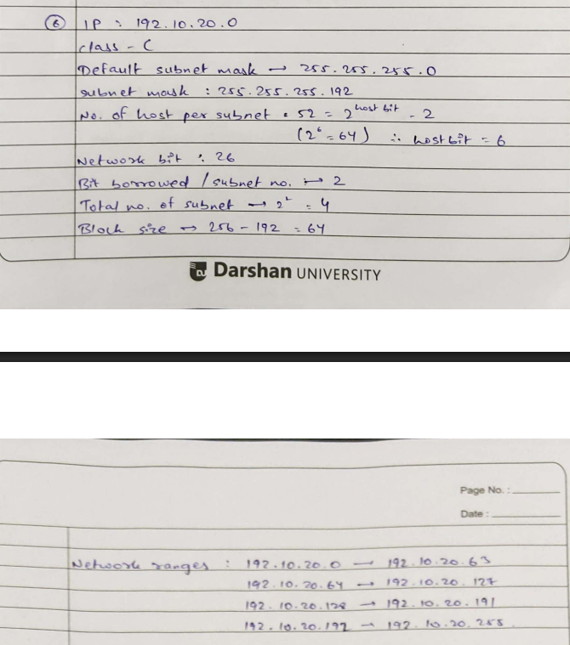

- Determining the Subnet mask for Devices A and B:
a) Device A: 172.16.17.30/20
b) Device B: 172.16.28.15/20

